**SOP for Uninstall Snow agent**

Please open command prompt via admin privilege

Go to mentioned path

Path : C:\Program Files\Snow Software\Inventory\Agent

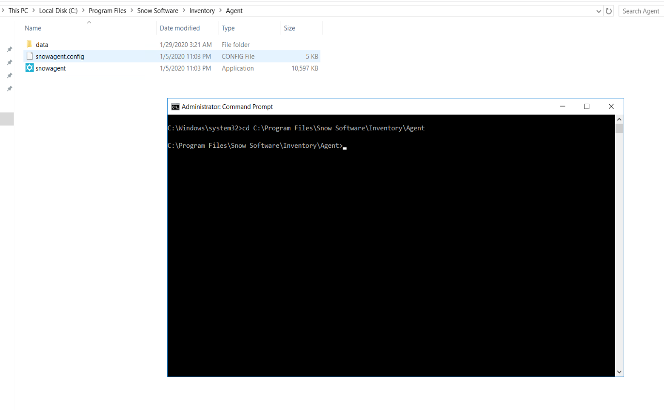

Then execute the mentioned command   
 **snowagent.exe stop**

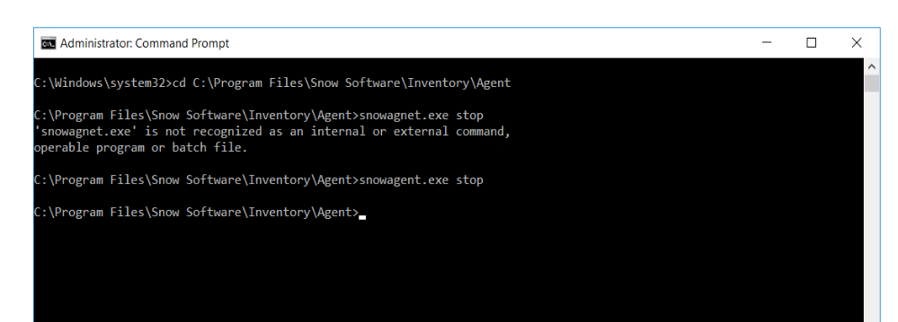

Then try the below command

**Snowagent.exe uninstall**

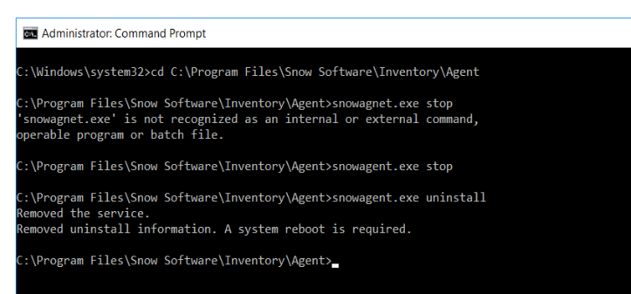

**Note: Don’t reboot the machine**

Then remove the files as mentioned below

